Assignment 2
STAT-540
Bruno Cavagnaro

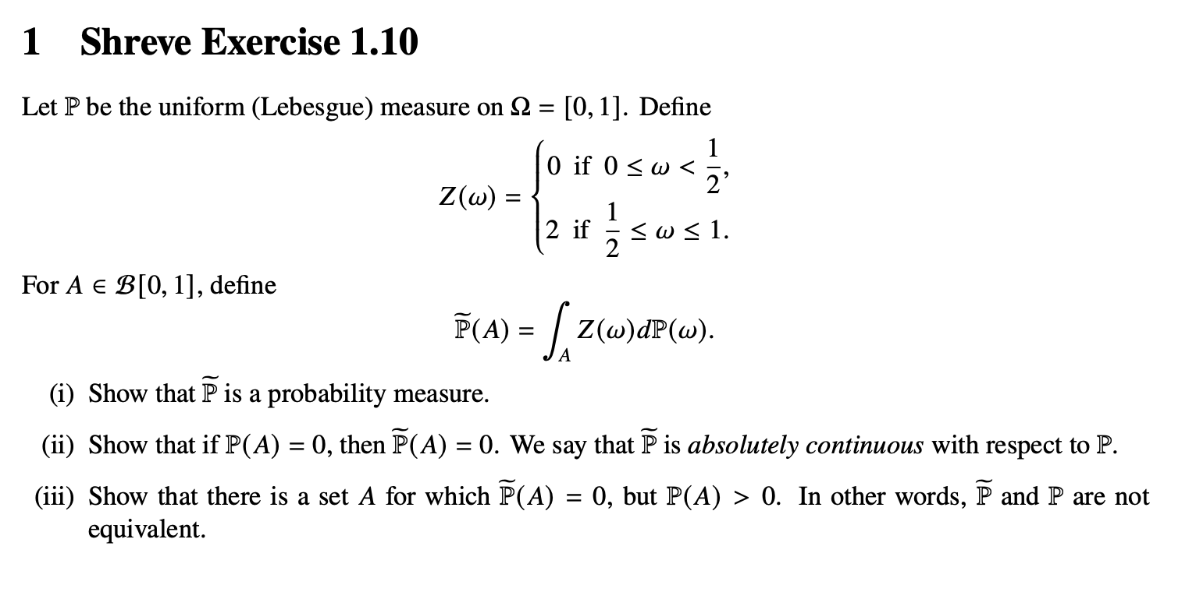
Solution:
- To prove that P_tilde is a probability measure, we need to verify the following properties:
  - Non Negativity:
$$Since z\left(w\right)≥O, for all w and Ρ is a measure, we have:$$
$$\tilde{P}\left(A\right)= \int_{A}{Z\left(w\right)dP(w)}≥0$$
  - Normalization:

$$\tilde{P}\left([0,1]\right)= \int_{0}^{1}{Z\left(w\right)dP(w)}= \int_{0}^{\frac{1}{2}}{0*dP(w)}+ \int_{\frac{1}{2}}^{1}{2*dP(w)}=0+2Ρ\left(\left[\frac{1}{2,1}\right]\right)=2* \frac{1}{2}=1$$

  - Countable additivity:

$$P\left(\bigcup_{n}{A_{n}}\right)= \int{\left(\bigcup_{n}{A_{n}}\right)}Z\left(w\right)dP\left(w\right)= \sum_{n}{\int{\left(A_{n}\right)Z\left(w\right)dP\left(w\right) } }$$
$$by countable additivity of Lebesgue Integral$$
$$= \sum_{n}{\tilde{P}(A_{n}) }$$

- If P(A) = 0, then A has a Lebesgue measure zero

$$\tilde{P}\left(A\right)=\int_{A}{Z\left(w\right)dP\left(w\right)}= \sum_{n}{\int{\left(A_{n}\right)Z\left(w\right)dP\left(w\right) } }$$
$$since Z\left(w\right) is bounded by \left(0≤Z\left(w\right)≤2\right) and P\left(A\right)=0, we have:$$
$$\tilde{P}\left(A\right)≤ \int_{A}{2dP\left(w\right)}=2*P\left(A\right)=2*0= 0$$
$$since \tilde{P}\left(A\right)≥0, by non-negativity, we conclude: \tilde{P}\left(A\right)=0$$

- To find the posible A that follow that condition, consider where A = [0,0.5):
$$Calculate \tilde{P}\left(A\right):\tilde{P}\left(\left[0,\frac{1}{2}\right]\right)=\int_{0}^{\frac{1}{2}}{Z\left(w\right)dP\left(w\right)}= \int_{0}^{\frac{1}{2}}{0*dP\left(w\right)=0}$$
$$Calculate P\left(A\right):P\left(\left[0,\frac{1}{2}\right]\right)=\frac{1}{2}>0$$
$$Therefore, A=\left[0,\frac{1}{2}\right] satisfies \tilde{P}\left(A\right)= 0, and P\left(A\right)=\frac{1}{2} , which is>0$$

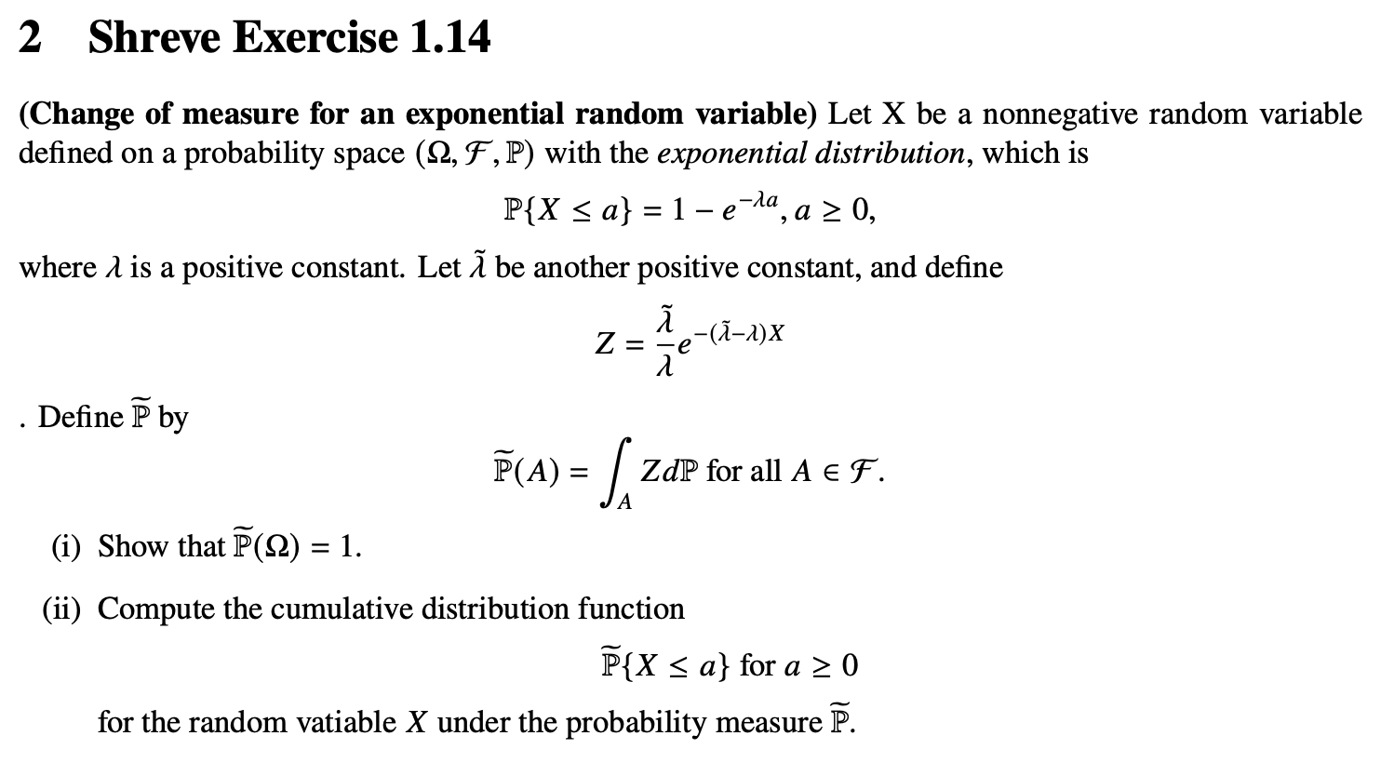
Solution:
- To show that P_tilde over the probability space is equal to 1:

$$\tilde{P}\left(Ω\right)= \int_{Ω}{ZdP}= \int_{Ω}{\frac{\tilde{λ}}{λ}e^{-\left(\tilde{λ}-λ\right)X}dP} = \int_{0}^{∞}{\frac{\tilde{λ}}{λ}e^{-\left(\tilde{λ}-λ\right)X} {λe}^{-\left(λ\right)X} dx= }$$
$$\int_{0}^{∞}{\tilde{λ}e^{-(\tilde{λ})X} dx= \tilde{λ}\left(\frac{-1}{\tilde{λ}}\right)} \left(e^{-\tilde{λ} ∞}-e^{-\tilde{λ} 0} \right)=1$$

- Cumulative distribution for X<=a, for a > 0:

$$\tilde{P}\left\{X≤a\right\}= \int_{0}^{a}{\frac{\tilde{λ}}{λ}e^{-\left(\tilde{λ}-λ\right)X}dP} = \int_{0}^{a}{\frac{\tilde{λ}}{λ}e^{-\left(\tilde{λ}-λ\right)X} {λe}^{-\left(λ\right)X} dx= \tilde{λ}\left(\frac{-1}{\tilde{λ}}\right) \left(e^{-\tilde{λ} a}-e^{-\tilde{λ} 0} \right)}=1-e^{-\tilde{λ} a}$$

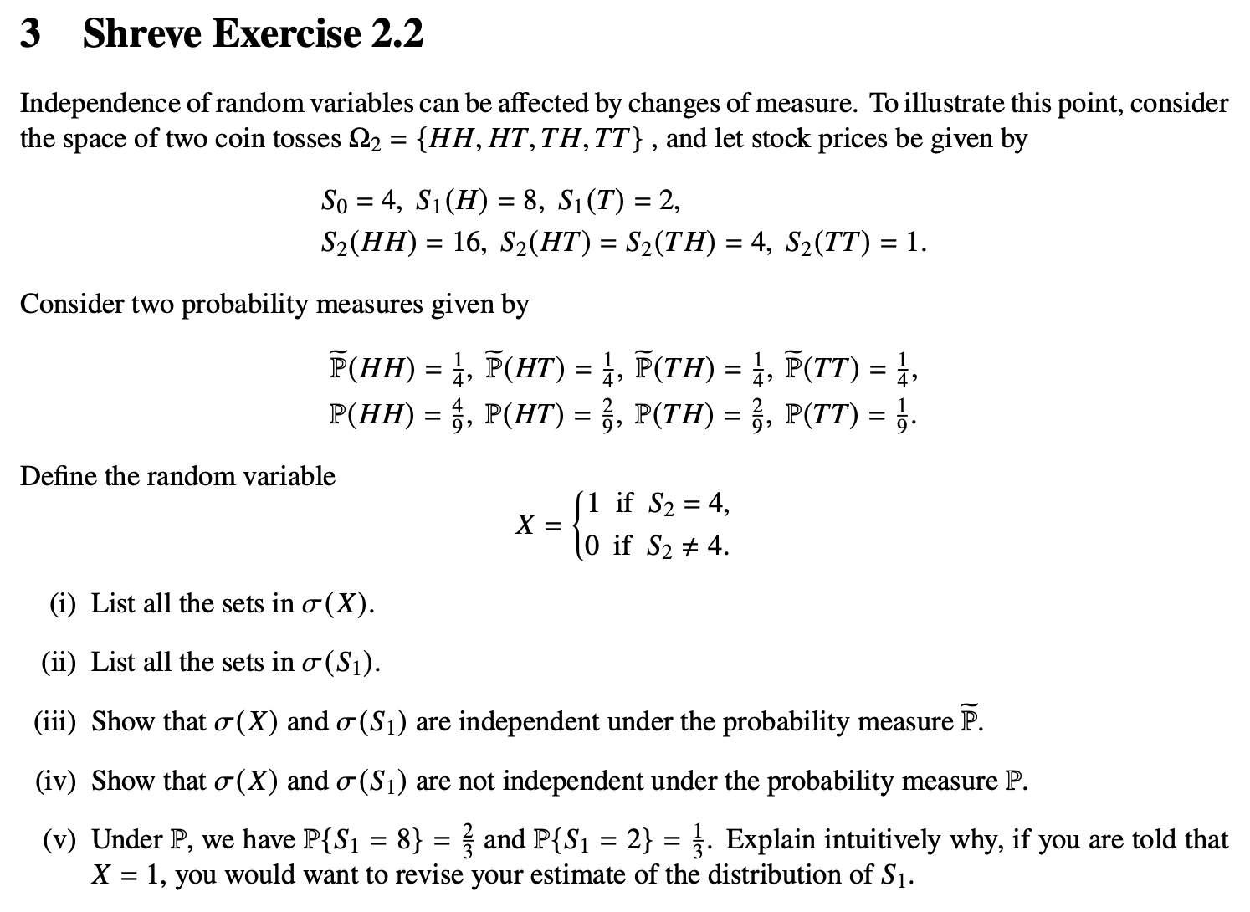
Solution:
- List all the sets in sigma(X):
$$The σ-algebra generated by X contains all sets that can be expressed in terms of X.$$
$$Since X takes values \left\{0,1\right\}:$$
$$- \left\{X=1\right\}: \left\{HT,TH\right\} (where S_{2}=4)$$
$$- \left\{X=0\right\}: \left\{HH,TT\right\} (where S_{2} ≠4)$$
$$σ\left(X\right)= \left\{∅ , \left\{HT,TH\right\} , \left\{HH,TT\right\}, Ω_{2}\right\}$$
- List all the sets in sigma(S1):
$$The σ-algebra generated by S_{1} contains all sets that can be expressed in terms of S_{1}.$$
$$Since X takes values \left\{2,8\right\}:$$
$$- \left\{S_{1} =2\right\}: \left\{TH,TT\right\} (first toss is tail)$$
$$- \left\{S_{1} =8\right\}: \left\{HT,HH\right\} (first toss is head)$$
$$σ\left(X\right)= \left\{∅ , \left\{HH,HT\right\} , \left\{TH,TT\right\}, Ω_{2}\right\}$$

- Show that sigma x and sigma s1 are independent under P_tilde:
$$The two σ-algebras are independent if for every A∈ σ\left(X\right) and B∈ σ\left(S_{1}\right):$$
$$\tilde{P}\left(A∩B\right)= \tilde{P}\left(A\right)* \tilde{P}\left(B\right)$$
Lets check all non-trivial combinations:

- Case 1:
$$A= \left\{HT, TH\right\}, B=\left\{HH, HT\right\}$$
$$\tilde{P}\left(A∩B\right)= \tilde{P}\left(HT\right)= \frac{1}{4}$$
$$\tilde{P}\left(A\right)= \tilde{P}\left(HT\right)+ \tilde{P}\left(TH\right)= \frac{1}{4}+ \frac{1}{4}= \frac{1}{2}$$
$$\tilde{P}\left(B\right)= \tilde{P}\left(HH\right)+ \tilde{P}\left(HT\right)= \frac{1}{4}+ \frac{1}{4}= \frac{1}{2}$$

$$\tilde{P}\left(A\right)*\tilde{P}\left(B\right)= \frac{1}{2}* \frac{1}{2}= \frac{1}{4}$$

- Case 2:
$$A= \left\{HT, TH\right\}, B=\left\{TH, TT\right\}$$
$$\tilde{P}\left(A∩B\right)= \tilde{P}\left(TH\right)= \frac{1}{4}$$
$$\tilde{P}\left(A\right)= \tilde{P}\left(HT\right)+ \tilde{P}\left(TH\right)= \frac{1}{4}+ \frac{1}{4}= \frac{1}{2}$$
$$\tilde{P}\left(B\right)= \tilde{P}\left(TH\right)+ \tilde{P}\left(TT\right)= \frac{1}{4}+ \frac{1}{4}= \frac{1}{2}$$

$$\tilde{P}\left(A\right)*\tilde{P}\left(B\right)= \frac{1}{2}* \frac{1}{2}= \frac{1}{4}$$

- Case 3:
$$A= \left\{HH, TT\right\}, B=\left\{HH, HT\right\}$$
$$\tilde{P}\left(A∩B\right)= \tilde{P}\left(HH\right)= \frac{1}{4}$$
$$\tilde{P}\left(A\right)= \tilde{P}\left(HH\right)+ \tilde{P}\left(TT\right)= \frac{1}{4}+ \frac{1}{4}= \frac{1}{2}$$
$$\tilde{P}\left(B\right)= \tilde{P}\left(HH\right)+ \tilde{P}\left(HT\right)= \frac{1}{4}+ \frac{1}{4}= \frac{1}{2}$$

$$\tilde{P}\left(A\right)*\tilde{P}\left(B\right)= \frac{1}{2}* \frac{1}{2}= \frac{1}{4}$$

- Case 4:
$$A= \left\{HH, TT\right\}, B=\left\{TH, TT\right\}$$
$$\tilde{P}\left(A∩B\right)= \tilde{P}\left(TT\right)= \frac{1}{4}$$
$$\tilde{P}\left(A\right)= \tilde{P}\left(HH\right)+ \tilde{P}\left(TT\right)= \frac{1}{4}+ \frac{1}{4}= \frac{1}{2}$$
$$\tilde{P}\left(B\right)= \tilde{P}\left(TH\right)+ \tilde{P}\left(TT\right)= \frac{1}{4}+ \frac{1}{4}= \frac{1}{2}$$

$$\tilde{P}\left(A\right)*\tilde{P}\left(B\right)= \frac{1}{2}* \frac{1}{2}= \frac{1}{4}$$
We prove that both sigmas are independent.

- Show that sigma x and sigma s1 are not independent under P:
$$The two σ-algebras are independent if for every A∈ σ\left(X\right) and B∈ σ\left(S_{1}\right):$$
$$\tilde{P}\left(A∩B\right)= \tilde{P}\left(A\right)* \tilde{P}\left(B\right)$$
Lets check all non-trivial combinations:

- Case 1:
$$A= \left\{HT, TH\right\}, B=\left\{HH, HT\right\}$$
$$P\left(A∩B\right)= P\left(HT\right)= \frac{2}{9}$$
$$P\left(A\right)= P\left(HT\right)+ P\left(TH\right)= \frac{2}{9}+ \frac{2}{9}= \frac{4}{9}$$
$$P\left(B\right)= P\left(HH\right)+ P\left(HT\right)= \frac{4}{9}+ \frac{2}{9}= \frac{6}{9}$$
$$P\left(A\right)*P\left(B\right)= \frac{4}{9}* \frac{6}{9}= \frac{24}{81}$$
$$Since :P\left(A∩B\right) ≠ P\left(A\right)*P\left(B\right), both sigmas are not independent under P$$

- Explain intuitively why, if you are told that 𝑋 = 1, you would want to revise your estimate of the distribution of 𝑆1:

$$P\left\{S_{1}=8\right\}=P\left(HH\right)+ P\left(HT\right)= \frac{6}{9}$$
$$P\left\{S_{1}=2\right\}=P\left(TH\right)+P(TT) = \frac{3}{9}$$
Given X=1, which means S2 = 4, so the outcome is either: HT or TH:
$$P\left\{S_{1}=8,X=1\right\}=P\left(HT\right)= \frac{2}{9}$$
$$P\left\{X=1\right\}=P\left(HT\right)+P(TH) = \frac{4}{9}$$
$$So P\left(S_{1}=2 \right| X=1)=\frac{P(S1=8,X=1)}{P(X=1)}= \frac{1}{2}$$
So from having probabilities of P(S1=8) =6/9 - P(S1=2) =3/9, after having S2 = 4, then it both changes to ½ for both. Under P the outcomes HH, HT, TH, TT are not equally likely (they have probabilities 4/9, 2/9, 2/9, 1/9). Learning that S₂ = 4 rules out HH and TT, leaving only HT and TH, which under ℙ have equal probability (both 2/9). This changes your belief about S₁ from favoring S₁ = 8 to being neutral between S₁ = 8 and S₁ = 2.
This demonstrates that dependence under ℙ means information about X provides information about S₁.

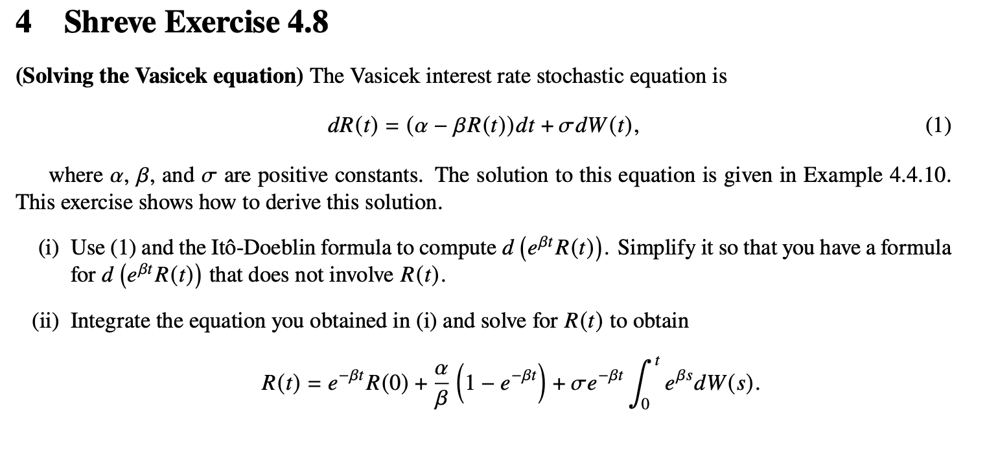

Solution:
- Use Itô-Doeblin formula to compute d(e^(βt)R(t))

$$Y\left(t\right)=e^{βt }*R(t)$$
$$Itô^{'}s formula: For Y\left(t\right)= f\left(t, R\left(t\right)\right), we have: d\left(Y\right)= \frac{∂f}{∂t}dt+\frac{∂f}{∂R}dR+\frac{1}{2}\frac{∂^{2}f}{∂^{2}R^{2}}{(dR)}^{2}$$

$$For f\left(t,R\right)= e^{βt}*R ,$$
$$\frac{∂f}{∂t}={βe}^{βt}*R,$$
$$\frac{∂f}{∂R}=e^{βt},$$
$$\frac{∂^{2}f}{∂^{2}R^{2}}=0$$

$$From equation \left(1\right): {(dR)}^{2}= σ^{2}{(dW)}^{2}= σ^{2}dt (using the rule {\left(dW\right)}^{2}= dt$$

$$d\left( e^{βt}*R(t)\right)=({βe}^{βt}*R\left(t\right)dt)+e^{βt}dR(t)+\frac{1}{2}\left(0\right)dt$$
$$d\left( e^{βt}*R(t)\right)=({βe}^{βt}*R\left(t\right)dt)+e^{βt}\left[\left(α-βR\left(t\right)\right)dt+σdW(t)\right]$$

$$d\left( e^{βt}*R(t)\right)={(βe}^{βt}*R\left(t\right)dt)+{αe}^{βt}dt-{(βe}^{βt}*R\left(t\right)dt) +σe^{βt}dW(t)= {αe}^{βt}dt +σe^{βt}dW(s)$$

- Integrate and solve for R(t)

$$\int_{0}^{t}{d\left( e^{βt}*R(s)\right)} =\int_{0}^{t}{{αe}^{βs}dt +σe^{βs}dW(s)}$$

$$e^{βt}R\left(t\right)-e^{0}R\left(0\right)= \frac{α}{β} e^{βt}- \frac{α}{β} +\int_{0}^{t}{σe^{βs}dW(s)}$$

$$e^{βt}R\left(t\right)= R\left(0\right)+ \frac{α}{β} \left({ e}^{βt}-1\right) +\int_{0}^{t}{σe^{βs}dW(s)}$$

$$multiply by e^{-βt}$$

$$R\left(t\right)= {R\left(0\right)e}^{-βt}+ \frac{α}{β} \left(1-e^{-βt}\right) +{σe}^{-βt}\int_{0}^{t}{e^{βs}dW(s)}$$

